**Bluetooth based home automation using mobile application**

**Introduction**

 In this project ,we are using Home Automation System Using Smartphone And Bluetooth. For this project we are going to Use Arduino Nano as a microcntroller and hc-05 bluetooth module for Conncetivity purpose. The Blynk app are used to control the whole system of this project.

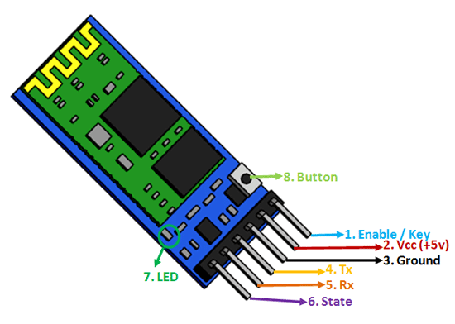

**Components :**

* Arduino nano
* HC-05 bluetooth module
* 8 channel relay module
* LED
* Resistor 470 ohm
* Battery and battery holder

**Apps: Blynk and Arduino IDE**

**Application**

.Wireless communication between two microcontrollers

2. Communicate with Laptop, Desktops and mobile phones

3. Data Logging application

4. Consumer applications

5. Wireless Robots

6. Home Automation

Objective

During this activity ,you will help students to achieve following objectives

* Understanding the principle and operation of HC-05 bluetooth module

1. Design algorithm and flowchart to home automation system

* Programming HC-05 bluetooth module with Arduino nano
* Interfacing HC-05 bluetooth module with ardion nano

**Program**

#define BLYNK_USE_DIRECT_CONNECT

// You could use a spare Hardware Serial on boards that have it (like Mega)

#include <SoftwareSerial.h>

SoftwareSerial DebugSerial(0,1); // RX, TX

#define BLYNK_PRINT DebugSerial

#include <BlynkSimpleSerialBLE.h>

// You should get Auth Token in the Blynk App.

// Go to the Project Settings (nut icon).

char auth[] = "AuthToken";

void setup()

{

// Debug console

DebugSerial.begin(9600);

pinMode (12, OUTPUT);

pinMode (11, OUTPUT);

pinMode (10, OUTPUT);

pinMode (9, OUTPUT);

pinMode (8, OUTPUT);

pinMode (7, OUTPUT);

pinMode (6, OUTPUT);

pinMode (5, OUTPUT);

pinMode (12, LOW); // Set All Pins Low Beacause At The Starting All Relays get ON, Results In All load

pinMode (11, LOW); // Connected Across Relay Module Get Turn On

pinMode (10, LOW);

pinMode (9, LOW);

pinMode (8, LOW);

pinMode (7, LOW);

pinMode (6, LOW);

pinMode (5, LOW);

DebugSerial.println("Waiting for connections...");

// Blynk will work through Serial

// 9600 is for HC-06. For HC-05 default speed is 38400

// Do not read or write this serial manually in your sketch

Serial.begin(9600);

Blynk.begin(Serial, auth);

}

void loop()

{

Blynk.run();

}

**Hardware**

**Instruction**

1. connect VCC and GND pin of HC-05 module with Arduino nano power supply pin and ground pin
2. connect Txd pin of module to Rxd pin of board and

Rxd pin of module to Txd pin of board.

1. connect relay module VCC and GND pin with Arduino board and connect pins (2,3,4,5,6,7,8,9) to arduino boards data pin (D12,D11,D10,D9,D8,D7,D6,D5).
2. Add Blynk library in your Arduino IDE
3. Sketch-Include Library-Manage libraries-Type Blynk-Install
4. Copy Following code & Upload to Arduino Nano

**Circuit diagram**

